AJRW -

Functionality
A fiscal year change in Asset Accounting is the opening of a new fiscal year in Asset Accounting for a company code. At the fiscal year change, the asset values from the previous fiscal year are carried forward cumulatively into the new fiscal year. Once the fiscal year change takes place, you can post to assets using value dates in the new fiscal year. At the same time, you can continue to post in the previous fiscal year

Scenario
New calendar year has begun.

Requirements
There is no necessity to close the previous Asset Accounting fiscal year in order to carry out fiscal year change i.e. open new financial year in Asset Accounting.
Asset fiscal year change must be run BEFORE G/L year end closing. Depreciation should have been completely posted.

Menu Path | Accounting → Financial Accounting → Fixed Assets → Periodic Processing → AJRW - Fiscal Year Change
Transaction Code | AJRW

1. Double Click on AJRW - Fiscal Year Change
Asset fiscal year change

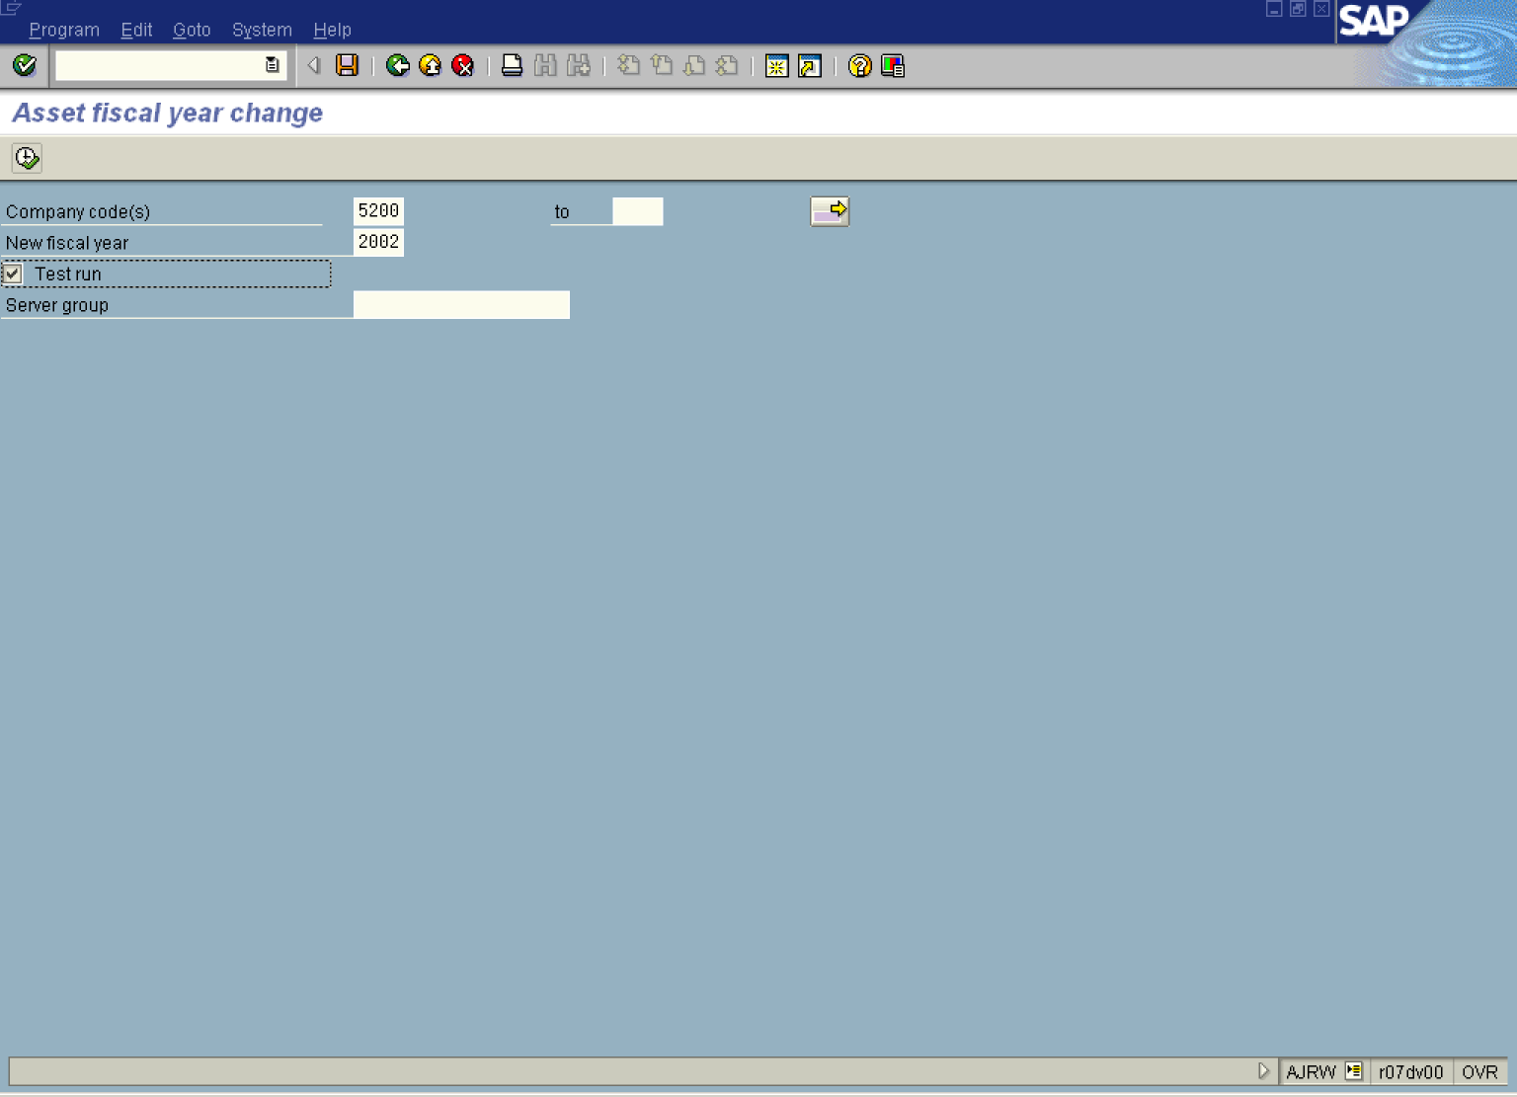
2. Update the following fields:

Field Name | Field Description | Values
Company code(s) | The company code is an organizational unit within financial accounting. | Example: 5200
New fiscal year | Period, 12 months as a rule, for which the company is to create its inventory and balance sheet. | Example: 2002
3. Click <checkbox> Test run .
Note: This option controls whether or not a test run takes place.
If Test run is active, the system only generates a log. Data is neither updated nor changed in the database. This process can be run in foreground.
If Test run is not activated, the system updates data in the database. This can ONLY BE RUN IN BACKGROUND.
4. Select ProgramExecute in background.

Background Print Parameters

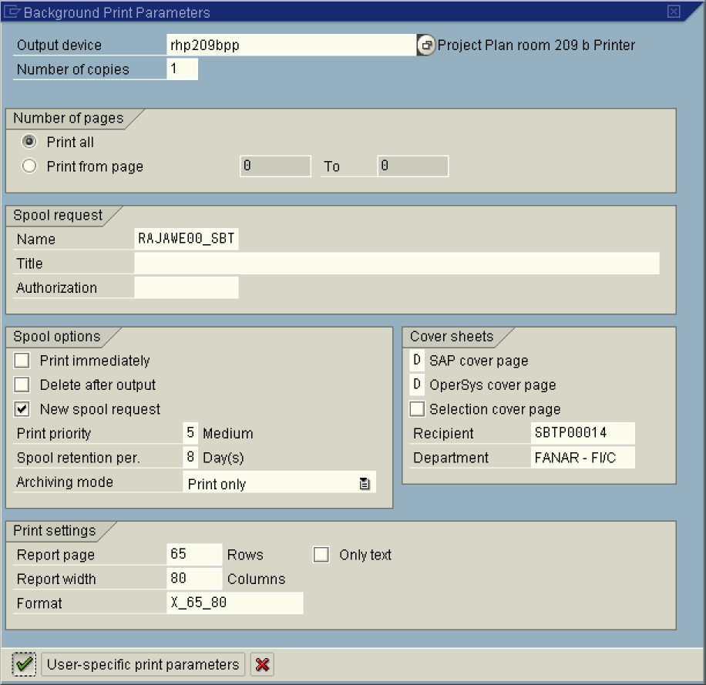
5. Update the following fields:

Field Name | Field Description | Values
Output Device | Code that identifies your printer.  NOTE: this can also be local to print on your the default windows printer. | Example: rhp209bpp. NOTE, this can also be local to print on your the default windows printer.
6. Click the Enter button.

Start Time

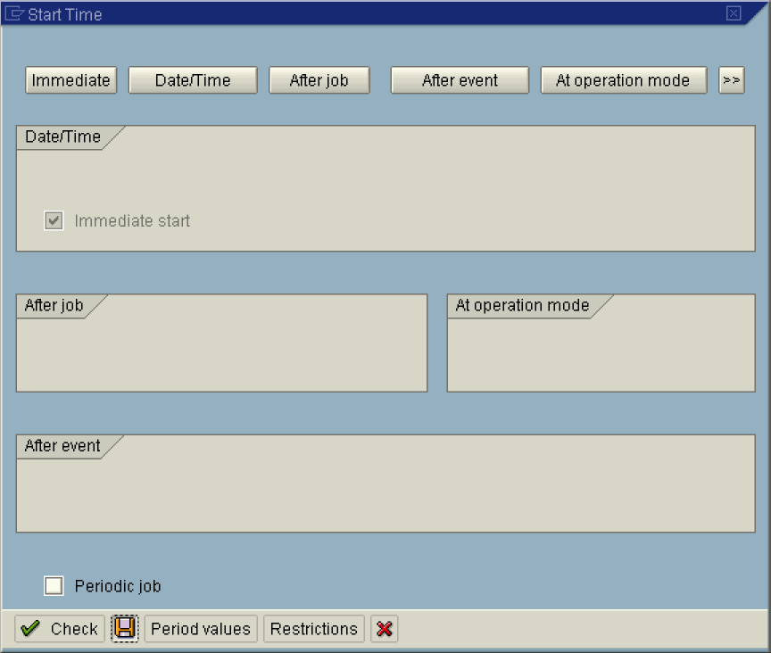

7. Click Immediate button.

Note: To run the job at a later time or after a specific event, select the relevant button. or .
8. Click the Save button.

Asset fiscal year change

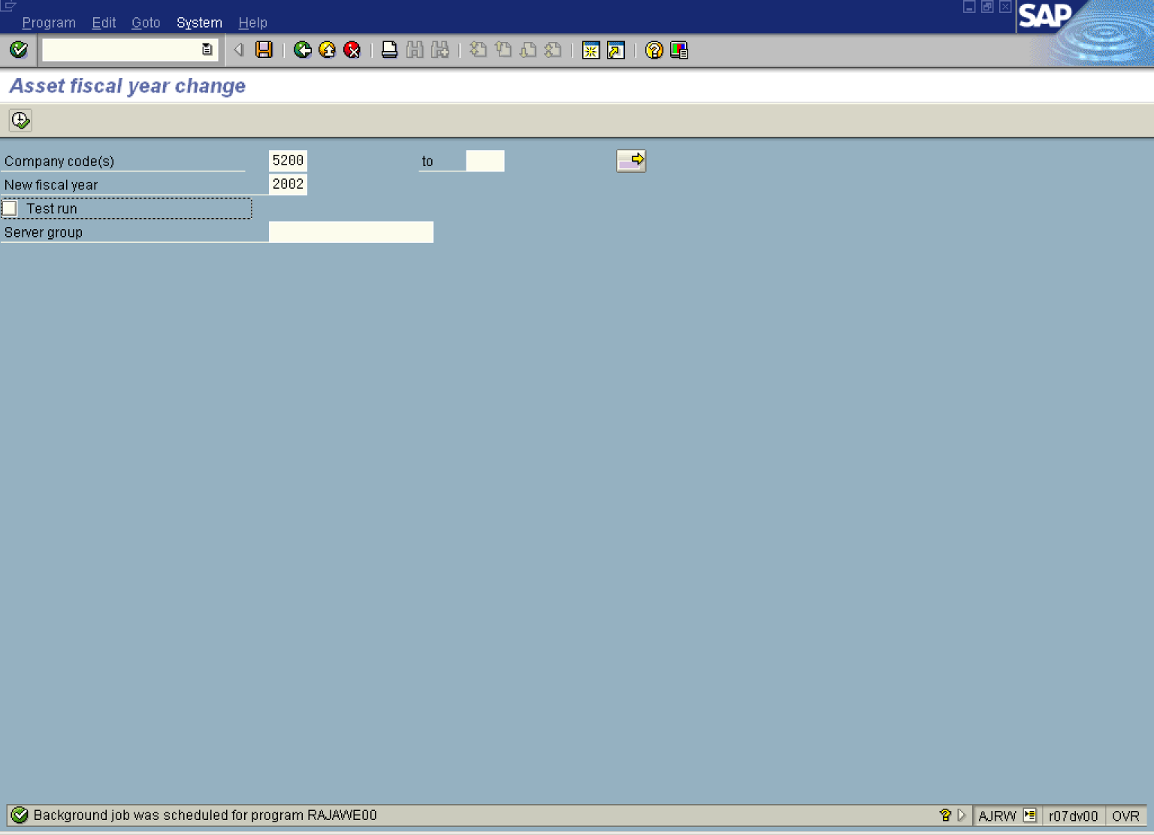

Note: The background job is created. The next step involves checking the status of this transaction.

9. Select SystemServices Jobs ServicesJob Overview
Note: This is to check the progress of the batch year end posting process.
Asset fiscal year change

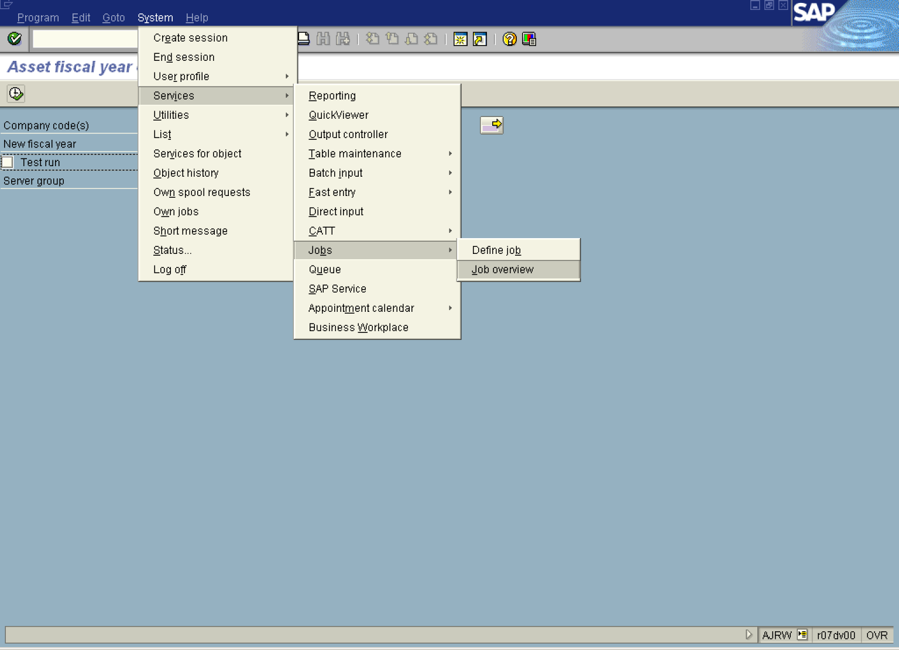

Simple Job Selection

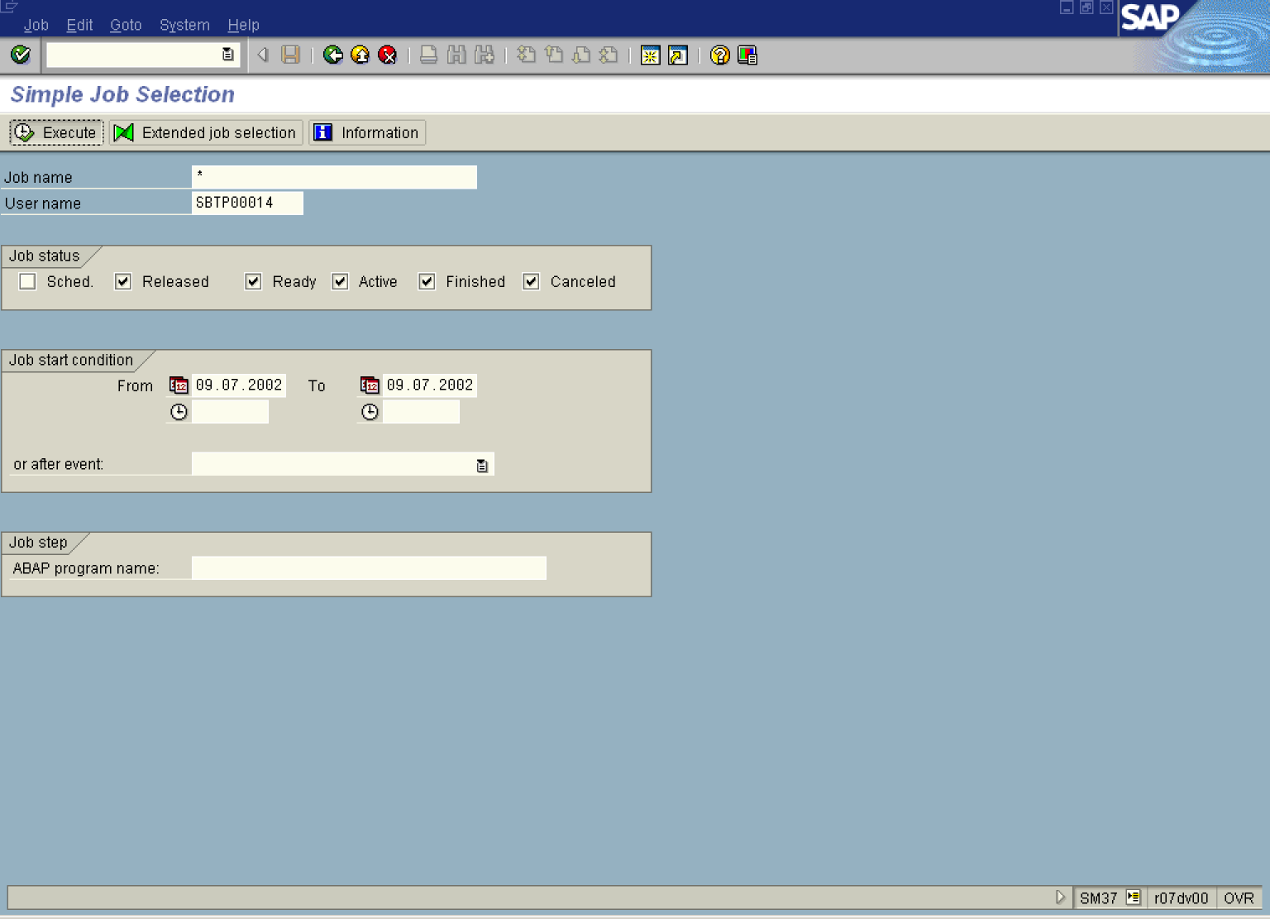
10. Click the Execute Button .

Job Overview

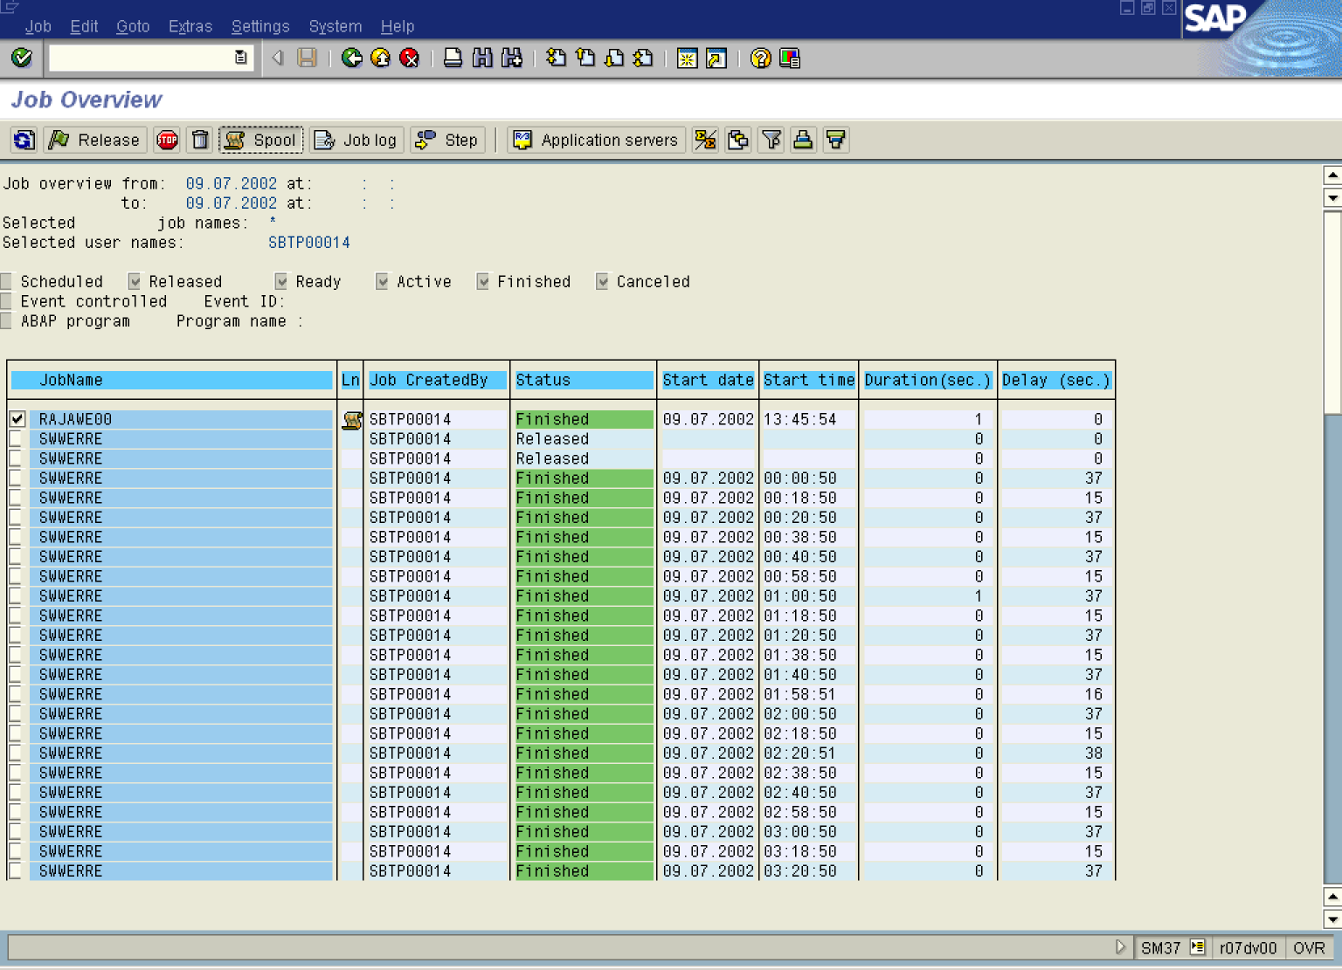

11. Select RAJAWE00 Button .
12. Click Spool Button .

Output Controller: List of Spool Requests

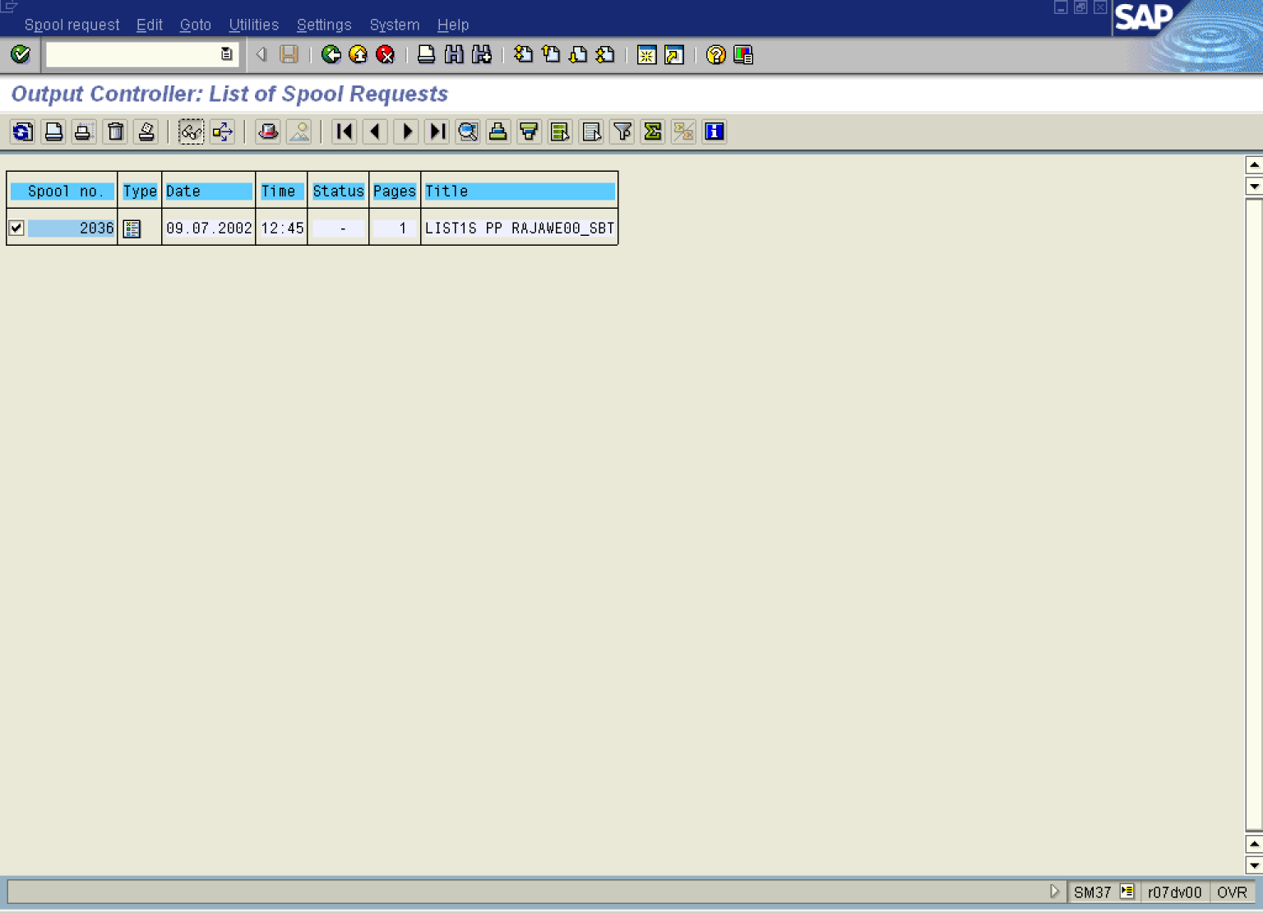
13. Click 2036 Button .
14. Click Display button.

Graphical display of spool request 2036 in system DS1

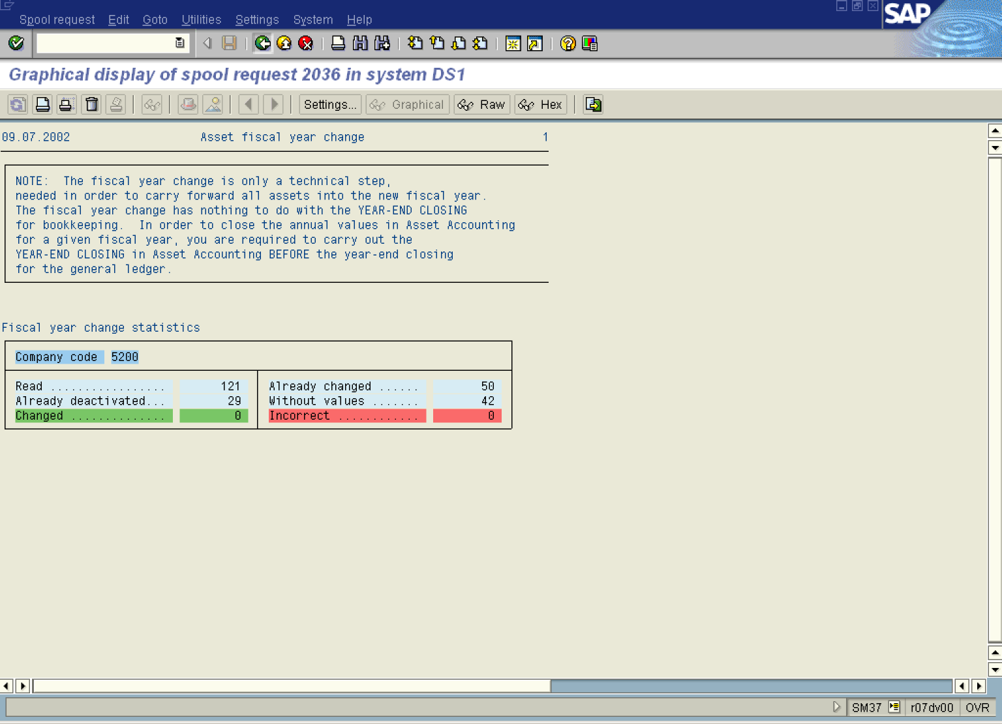
Note: The system log will identify any errors that may have occurred in the process.
15. Click Back to exit the transaction

